肌肉骨骼症狀調查表（Nordic Musculoskeletal Questionnaire, NMQ）

Data： (yyyy/mm/dd)
A、Basic information
Name | Gender | Date of birth | Extension | Job description
Department | Job title | Seniority | Strong hand
 |  |  | □Left □Right

1. Do you have any type of pain persisting for more than two (2) weeks in length, pain sort like fatigue, soreness, numbness, tingling or joint activity are limited.?
□ NO, end this evaluation □ Yes, continue evaluation

2. How long has the body part been sore, uncomfortable or affecting joint activity? (Please fill in the longest duration for different pain areas)
□1 month □3 month □6 month □1 year □3 year □3 year and above

B、Other Musculoskeletal History
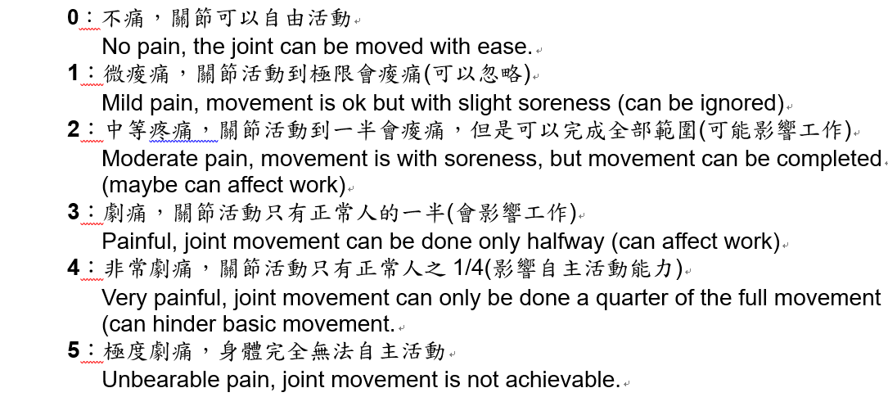
C、Symptoms evaluation

Scale the pain from one (1) to five (5) using the above description

