2025桃園國際學生節簡章
2025 International Student Festival in Taoyuan Prospectus

- 活動宗旨Objective
本活動旨在促進在台國際學生與本地學生的交流，透過運動競賽、藝術展演、異國美食與文化市集等多元活動，增進彼此了解，打造友善多元的國際校園環境。
The festival aims to foster interaction between international and local students in Taiwan through sports competitions, cultural performances, exotic food and cultural markets, and more, creating a friendly and diverse campus environment.
- 指導單位Advisory Organizations: 桃園市政府、桃園市議會
Taoyuan City Government, Taoyuan City Council
- 主辦單位Organizer: 桃園市政府青年事務局Department of Youth Affairs,
Taoyuan City Government
- 活動資訊 Event Information
- 日期 Date：2025年11月15日 November 15, 2025
- 時間 Time：10:30 AM – 5:00 PM
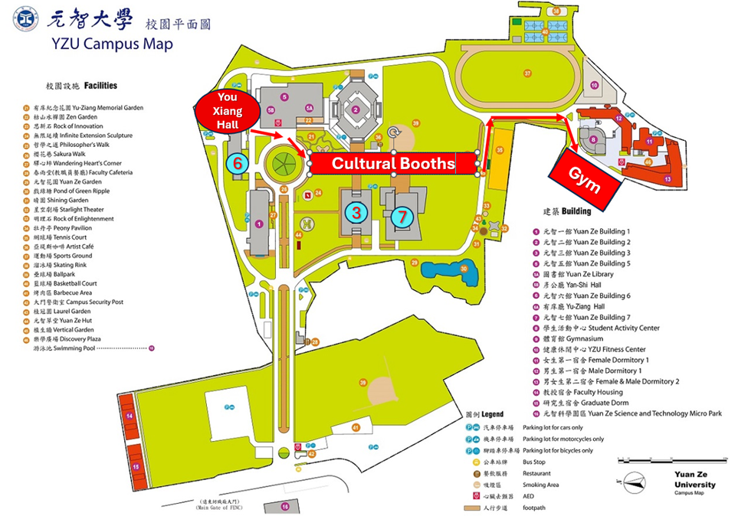
- 地點 Venue：元智大學
- 活動流程 Festival Program

Time | Activity | Venue
10:30–11:00 | 活動報到 Registration | 有庠廳入口 You-Xiang  Hall Entrance
11:00–11:35 | 開幕儀式 Opening Ceremony of Festival | 有庠廳  You-Xiang Hall
11:35-11:45 | 開球儀式Opening Ceremony of Sports | 紅磚道  Red Brick Path (Booth Market & Main Stage)
11:45-17:00 | 異國美食、文化體驗  International Cuisine & Culture | 紅磚道  Red Brick Path (Booth Market & Main Stage)
13:00–16:30 | 羽毛球挑戰賽Badminton Competition  匹克球對抗賽 Pickleball Competition  太空足球趣味賽 Bubble Soccer Game | 體育館Gym
13:00–16:30 | 排灣族琉璃手鍊  Paiwan Glass Bead Bracelet | 三館1樓教室 1st floor Rooms in Building 3
16:30–17:00 | 頒發運動獎項和抽獎  Sports Awards & Lucky Draw | 主舞台  Main Stage
17:00 | 接駁車離場  Shuttle service for departure | 指定接送區  Pickup Points
- 招募對象 Participants
桃園市各大專校院學生，以國際學生優先，預計招募150人以上。
Students from universities and colleges in Taoyuan City (priority given to international students). At least 150 participants expected.
- 報名方式 Registration
- 一律採網路報名 Please register online.
- 每人以1-3選填運動競賽志願，由主辦方依各校報名最多的運動分組配對。
Participants should select 1 to 3 sports in order of preference. Final grouping and pairing will be determined by the organizer, prioritizing the sports with the highest cumulative registration numbers across all schools.
- 當天提供中壢火車站和桃園高鐵站往返接駁，請在報名時登記。
Shuttle bus service between Zhongli Train Station and Taoyuan HSR Station will be provided on the event day. Please register when signing up.
- 報名連結 Registration link: https://forms.gle/o96BnU81KmX17xVk9
- 請於2025年10月25日前完成報名。Please register by October 25, 2025.
- 活動項目 Activities
  - 運動競賽 Sports Competitions：羽毛球團體挑戰賽、匹克球友誼對抗賽、太空足球趣味賽（每組至少參加一項）。Badminton Team Challenge, Pickleball Friendly Match, Bubble Soccer Fun Game (each team must join at least one).
競賽規則Competition Rules
- 羽毛球 – 每隊報名8 人，共 8 隊，先得 11 分者獲勝，比賽時間 10 分鐘，排名依得分與失分計算。
Badminton – 8 players per team, 8 teams in total. First to 11 points wins. Each match lasts 10 mins. Rankings are determined by points scored and conceded.
- 匹克球 – 每隊報名8 人，共 8 隊，先得 5 分者獲勝，比賽時間 10 分鐘，排名依得分與失分計算。
Pickleball –8 players per team, 8 teams in total. First to 5 points wins. Each match lasts 10 mins. Rankings are determined by points scored and conceded.
- 泡泡足球 – 每隊報名6人，共 6 隊，比賽時間 10 分鐘（5 分鐘換邊），平手時以 10 公尺無守門員的 PK 方式決勝。
Bubble Soccer – 5 players per team, 6 teams in total. Each match lasts 10 minutes (switch sides at 5 minutes). In case of a tie, the winner will be decided by 10-meter penalty kicks without a goalkeeper.
  - 異國美食與文化市集 International Foods & Culture Market
22個以上多元美食與文化攤位，體驗世界風味，並有原住民舞蹈、國際音樂、異國才藝等多元表演。
Over 22 diverse booths featuring global cuisine and cultural experiences, along with vibrant performances such as indigenous dance, international music, and multicultural talents.
  - 互動抽獎 Lucky Draw
Special Award – 1 winner | iPad 11 128G / Silver
Grand Prize – 1 winner | Apple Watch SE
First Prize – 3 winners | AirPods (4th Gen, Standard)
Second Prize – 5 winners | Logitech Wireless Keyboard & Mouse Set
Third Prize – 14 winners | Seven-Eleven Gift Card
  - 免費餐券、紀念品、參賽證書。
Free meal vouchers, souvenirs, and participation certificates.
    - 運動毛巾Sport Towel
    - T-Shirt (尺寸表Size Chart)
尺碼  Size | 衣長  Length | 半胸圍  Half Chest | 肩寬  Shoulder Width | 袖長  Sleeve Length | 適合身高  Suitable  Height | 適合體重  Suitable Weight
XS | 62 | 43 | 39 | 20 | 155-160 cm | 40-50 kg
S | 65 | 46 | 42 | 20 | 160-165 cm | 50-60 kg
M | 68 | 49 | 45 | 20 | 165-170 cm | 60-70 kg
L | 71 | 52 | 48 | 20 | 170-175 cm | 70-80 kg
XL | 73 | 55 | 51 | 20 | 175-180 cm | 80-90 kg
2XL | 75 | 58 | 54 | 21 | 180-185 cm | 90-100 kg
3XL | 78 | 62 | 58 | 21 | 185-190 cm | 100-110 kg
4XL | 81 | 65 | 61 | 22 | 190-195 cm | 110-120 kg
5XL | 83 | 68 | 64 | 23 | 195-200 cm | 120-125 kg
- 聯絡資訊 Contact
元智大學華語中心 YZU Mandarin Learning Center
Michelle Huang / 03-4638800 #2481/2491 / mich@saturn.yzu.edu.tw

本簡章如有未盡事宜，主辦單位得隨時補充或修正之；如遇當日參與人數或時間等狀況需要，主辦單位有權修改或調整競賽規則，並保有最終解釋權。
The organizer reserves the right to make amendments or supplements to this prospectus if necessary. The organizer also reserves the right to modify or adjust the competition rules should there be any necessity arising from the actual number of participants or time constraints on the day of the event, and retains the right of final interpretation.

