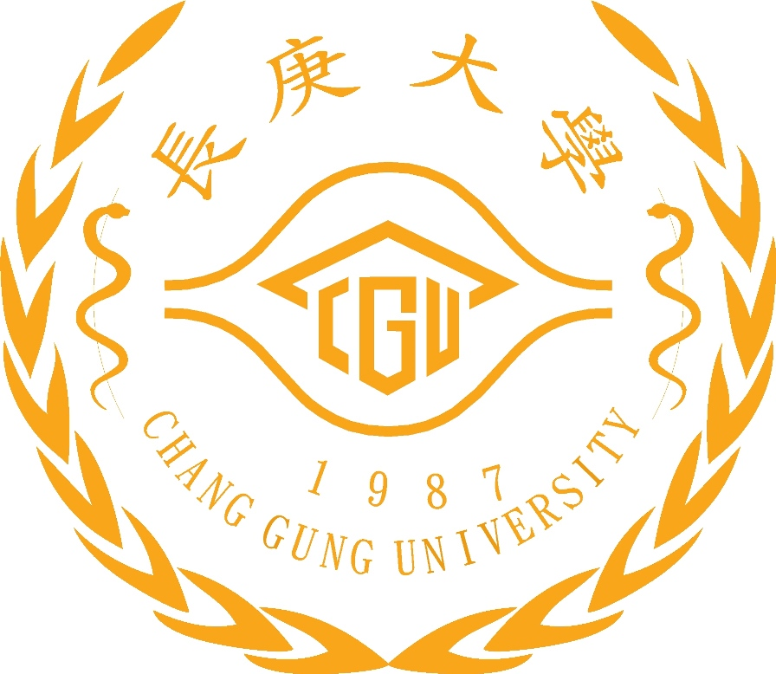 | 長庚大學外薦非學位生報到單  Chang Gung University Registration Form for Inbound Non-Degree Student
基本資料Personal Information (completed by the applicant)
姓名Name
國籍Nationality |  |  | 性別Gender
就讀學校Home University
護照號碼  Passport No. |  |  | 出生日期  Date of Birth
E-mail Address |  |  | 電話Phone No. in Taiwan
本校接待單位  Host Unit |  |  | 交流身分別 Academic Level | □ Undergraduate  □ Graduate
來校期間Duration |  | From ______ (Y) ______ (M) ______ (D) to ______ (Y) ______ (M) ______ (D)
宿舍房號  Dorm Room No. |  | - Chong De □ Ju De □ Yi De □ Yun De □ Ming De  Room No:
本人保證以上資料均由本人填寫，正確無誤。I certify that I have completed this form by myself, and all the information I have given is correct.
學生簽名Student’s signature: 日期Date:

本校聯絡人Information of Contact Person (assigned by the host professor)
姓名Name |  |  | 系級Dept.
學號Student ID No. |  |  | 電話Lab No.
手機Cell Phone No. |  |  | E-mail
連絡人簽名Signature：
保證人(需為本校專任教職員 signed by CGU faculty member or staff)
姓名Name |  | 單位Dept.
職稱 Title |  | 電話Lab No.
手機Cell Phone No. |  | E-mail
保證人同意對申請人所借閱圖書負完全責任。
保證人簽名：
國際事務處For OIA staff use only
承辦人員核章： |  | 主管核章：
證件流水號：
備註 Remarks:
- 本報到單僅供來校之境外非學位生（無本校學號者）申請使用圖書館館藏資源用，請各申請單位送交國際事務處辦理。
This registration form is intended solely for non-degree international students without a CGU student ID number who wish to apply for library access. Please submit the completed form to the Office of International Affairs (OIA).
- 請聯絡人協助境外非學位生持本單至圖書館登記。
The contact person is requested to assist the non-degree international student in bringing this form to the Library Circulation Desk for registration if they intend to borrow books from the CGU Library.
- 於學生離校前，請聯絡人協助辦理以下離校程序，並將本表繳回國際事務處。
Before the student leaves CGU, the contact person must assist in completing the deregistration procedure, and return this form along with the non-degree student ID card (if applicable) to the Office of International Affairs (OIA).

長庚大學外薦非學位生離校程序單
Deregistration Procedure Form for Non-Degree Students
姓名Name |  |  |  | 本校接待單位  Host Unit
預定離台日Expected Departure date |  |  |  | 宿舍房號  Dorm Room No. |  | - Chong De □ Ju De  - Yi De □ Yun De □ Ming De  Room No:
Procedure
程序Steps | 承 辦 單 位  Administrative office |  | 辦理事項  Description |  | 承辦單位簽章  Executive Signature |  | 辦理情形  Notes
1 | 圖書館  Library |  | 借書紀錄查核  Verification of Circulation Record  (Ensure all borrowed items have been returned and any overdue fines have been paid.)
2 | 國際事務處  Office of International Affairs |  | 離校程序單繳回查核  Submission and Verification of Deregistration Procedure Form  (Ensure that the completed deregistration procedure form has been returned.)

